Cognizant Deep Nurture 4.0

Design Patterns and Principles

**Candidate Name:** Rohit Tudu  
**Superset ID:** 6393839

**Exercise 1: Implementing the Singleton Pattern**

**Scenario:**

You need to ensure that a logging utility class in your application has only one instance throughout the application lifecycle to ensure consistent logging.

**Steps:**

1. **Create a New Java Project:**
   * Create a new Java project named **SingletonPatternExample**.
2. **Define a Singleton Class:**
   * Create a class named Logger that has a private static instance of itself.
   * Ensure the constructor of Logger is private.
   * Provide a public static method to get the instance of the Logger class.
3. **Implement the Singleton Pattern:**
   * Write code to ensure that the Logger class follows the Singleton design pattern.
4. **Test the Singleton Implementation:**
   * Create a test class to verify that only one instance of Logger is created and used across the application.

**Solution checklist**

1. Created a new Project Named **SingletonPatternExample**
2. Created a private static instance of Logger
3. Implemented Logger Constructor
4. Tested Logger method

**Screenshots**

**File Name: Main.java**

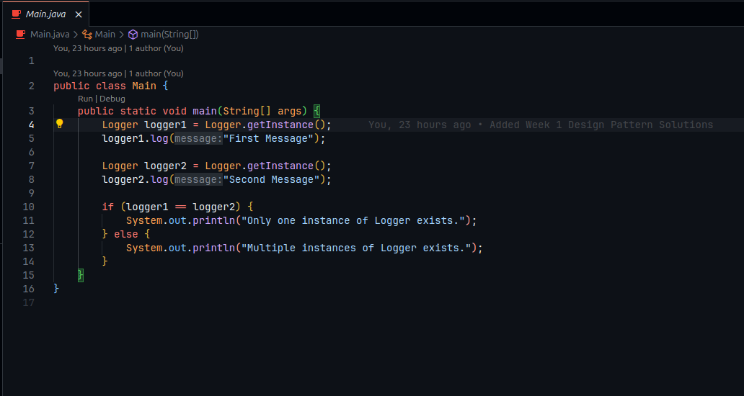

**File Name: Logger.java**

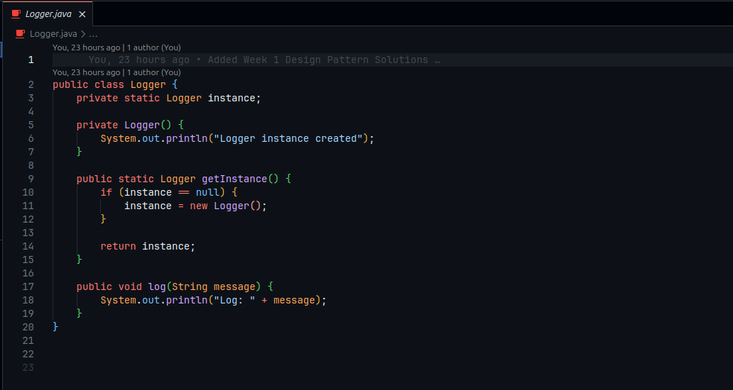

# Output: